DANANG SOFTWARE CORPORATION

SOFTECH-APTECH


Guiding faculty : Lê Thanh Tùng
Members : Ngô Quang Huy (Leader)
Huỳnh Quang Vinh
Vũ Long
Nguyễn Anh Tấn
Lê Xuân Trung
Group : 03
Batch : 55B

Da Nang, 25th July 2012





This is to certify that
Mr./Ms.
has successfully designed and
developed
_____________________________
Submitted by:
Date of Issue: ________
Authorized Signature: ___________

--------------------------Table of Contents------------------------

I.Task Sheet

Project Title:  MySweetHome |  | Period: 1 month
No. | Task | Actual Start Date | Actual Days | Team Member Name | Status
1 | Problem Definition | 25/07/2012 | 2 | Ngô Quang Huy  Vũ Long  Huỳnh Quang Vinh  Nguyễn Anh Tấn  Lê Xuân Trung | √
2 | Customer Requirement Specification | 25/07/2012 | 2 | Ngô Quang Huy  Vũ Long  Huỳnh Quang Vinh  Nguyễn Anh Tấn  Lê Xuân Trung | √
3 | Project Plan | 25/07/2012 | 1 | Vũ Long | √
4 | Architecture and Design of the Project | 27/07/2012 | 3 | Ngô Quang Huy  Vũ Long  Huỳnh Quang Vinh  Nguyễn Anh Tấn  Lê Xuân Trung
5.1 | Database Design/Structure | 30/08/2012 | 3 | Ngô Quang Huy
5.2 | Data Flow Diagram |  | 3 | Huỳnh Quang Vinh
6 | User case | 02/08/2012 | 2 | Vũ Long
7 | Entity Relationship(ER) Diagram | 4/08/2012 | 1 | Ngô Quang Huy  Vũ Long  Huỳnh Quang Vinh  Nguyễn Anh Tấn  Lê Xuân Trung
8.1 | Design base GUI | 5/08/2012 | 3 | Ngô Quang Huy  Vũ Long  Huỳnh Quang Vinh  Nguyễn Anh Tấn  Lê Xuân Trung
8.2 | Design Home page |  | 3 | Ngô Quang Huy  Vũ Long  Huỳnh Quang Vinh  Nguyễn Anh Tấn  Lê Xuân Trung
9 | Coding | 8/08/2012 | 20 | Ngô Quang Huy  Vũ Long  Huỳnh Quang Vinh  Nguyễn Anh Tấn  Lê Xuân Trung
10.1 | Testing web application | 28/08/2012 | 2 | Ngô Quang Huy  Vũ Long  Huỳnh Quang Vinh  Nguyễn Anh Tấn  Lê Xuân Trung
10.2 | Finishing documentation |  | 2 | Ngô Quang Huy  Vũ Long  Huỳnh Quang Vinh  Nguyễn Anh Tấn  Lê Xuân Trung
11 | Ending project and submitting to India | 31/08/2012 | 1 | Ngô Quang Huy

II. Problem Definition

INTRODUCTION TO SWEET HOME

SweetHome is a company that deals in real estate business. They started off in a city by doing lot of surveys to get the information about the local market, available properties, rates etc. and then they started publishing a magazine named “MySweetHome” in order to reach to the people.
In early days of their business they used to publish the magazine on quarterly basis but growing business made them to publish the magazine monthly and also opened an office in the city. Now they have offices in different other cities of the state. Because of their services they have attracted a vast number of customers in very short duration of time.
The staff answers the simple queries of the customers on phone but for details like charges, detailed procedures; they have to come down to the office.
The company has tie-up with certain banks in the country with the help of these it assists customers in arranging for the loan. Each bank has its own terms and conditions about providing the loan.
The company aims to break new ground by harnessing the power of technology and revolutionizing processes to buy a home for the customers a truly enjoyable and hassle-free experience.
The company deals in buying and selling the properties also assists in providing accommodation on rental basis and as paying guests. They have large database of Residential, Commercial, Land / Plots in the country.
If any customer walks into the office, he is required to fill an enquiry form. Then based on his preferences properties or house or plots are shown to him and then the further processing of buying or selling takes place.
But as the business is expanding day by day, the company has decided to reach to the people though web-site
So taking into consideration the expanding business, the company planned to host the primary information via MySweetHome, where dreams come true…..
For this purpose, they had us build a smart web-service. It is considered as a way resolve all estate-business problems for buying, rent, advertising or something like that.

- Goals of project

SweetHome website has been developed to achieve these goals:

- Allow user register their estate as buyer or seller.

- Organize transactions between the buyer and seller through website

- Allow user advertising or searching the property included many features: location, area, prices, etc.

- Create space for all questions concerned to service, and then user will receive reply-email from web service

- Request Requirement Analyzes

Website built with many functions below:

- Build an attractive home page

- Home page will implement interface include:
- Allow user login as their permission
- Allow user register new account

- Allow user to search database of estate based on difference criteria:
- Buyers want to buy new home, he can search based on:
- Price(minimum/maximum)
- Square footage
- city
- location/ specific area in the city
- No. of bedrooms
- No. of bathrooms
- Type(i.e. Residential Land, Commercial, Condominium, Townhouse, Multi-unit dwelling)

- Buyers want a home for rent, he can search based on:
- Amount to be paid as a deposit
- Rent
- City
- Location/ specific area in the city
- No. of bedrooms
- No. of bathrooms

- The guests can search for home based on:
- Deposit
- Rent

- The Sellers can provide their information for sale such as:
- City where the house is located.
- Location/ particular area in the city.
- price( fixed/ negotiable)
- No of bedrooms.
- No. of bathrooms.
- Type (i.e. Residential Land, Commercial, Condominium, etc)
- Extra facilities available.
- Convenient Modes of transport.
- With or without furniture/interiors.
- Image.
- Mode of payment.
- Contact details

- The Sellers can provide the accommodation on rental based on criteria:
- City
- Location
- Deposit
- Rent
- No. of bedrooms
- No. of bathrooms
- Image
- Modes of payment

- The Sellers can provide the accommodation as a paying guest based on criteria:
- City
- Location
- Deposit
- Rent

- Hardware and software requirements:

- Hardware requirements:
- Intel Pentium IV 2.6 GHz.
- Ram 256MB.
- Hard disk requires 512MB free.

- Software requirements:
- Microsoft Windows 2000/ XP SP2/Vista/7
- FireFox3/Chrome/IE8 or higher
- Notepad/HTML editor.
- Dream weaver
- Microsoft .net framework 3.0 or higher.
- Microsoft Visual Studio 2008 or higher.

- Customer Requirements Specification

    - User of the website

- Guest

- Seller

- Buyer

- Admin

    - Website functions:

- Design attractive home page

- Log in

- Log out

- Design Register page

- Design directory space to store buyers, sellers and guest information

- Design FAQ's page

- Design About page

- Display 10 news with highest rate

- Guest :
- Allow view account information on system
- View publicized news for detail
- Allow send email for requests to company mailbox

- Seller :
- Allow post, edit, delete the news of estate for sale quickly
- Allow post, edit, delete the news of estate for rent quickly
- Pay fee for register publicize news
- View information based on fixed criteria
- Manage account (view, change password)
- View the history that seller post news

- Buyer:
- Allow search estate information for basic or advance
- Manage account (view, change password)
- Manage favorite house list.

- Admin:
- Manage user account (add, edit, delete)
- Disable or enable account
- Manage all information about publicized news(approve or refuse news )
- Manage all subscribed package
- Manage all publicized news
- Manage currency
- Manage region/ city/ district
- Manage directory of estate
- Manage transaction process
- Update necessary information of estate business
- Check out all publicized news before approve
- Make a report of website based on 2 criteria: traditional customer, favorite type of news package

- Use Case

4.1 Guest

4.1.1 Send Mail To Administrator
- Actor:Guest
- Overview: After login on the website,select function:Contact.
- Contact-condition: Contact-condition: Login to website
- Scenarios:
Actor | System
- After login on the website,select function:Contact
- At the contact form
- Enter the contact information such as "Full Name", "Address", "Email", "Phone", Title "," Content "
- Click button “Contact”. | - Send notification system success or error message if errors occur please send information.

4.1.2 Register Member
- Actor: Guest
- Overview: Visitors to the website, select vien.O function register can choose this type of members as the "Buyer" or "Seller". Visitors complete and accurate information to register: Email and full name, password, living area, telephone ...
- Pre-condition: Member had login on the website
- Register-condition: Registration conditions: Subscribers will be successful for grant Admin to log into the site to post the package is selected charges
- Scenarios:
Actor | System
- Visitors to the home page, select the function register.
- Complete the necessary information:  - Fill basic information:  Select type of estate: UserName,Password,Email,FullName,Date of Birth,Gender,Address….  Select Role: User,Seller..  - Description details:  Role,Type of Member  - Register images(The subscribers)  - Contact information:  Name, Telephone, Address, Email. | - System check the validity of user input information
- Click button “Register”.  - User login to mail box, click on the link sent to the system to activate your account. | - If valid, the notification system sent an email to activate your account to the mail box that the customer has registered. If invalid, the error system in certain cases.  - Check system activation information and allow activation.  Note: the customer's account can not login to the system until the customer that activates your account.

4.1.3 View Estate
- Actor:Guest
- Overview: After login on the website,select function:Form Selling Estate or Form Renting Estate
- Contact-condition: Contact-condition: Login to website
- Scenarios:
Actor | System
- After login on the website,select function:Form Selling Estate or Form Renting Estate
- At the Estate form
- Click “Estate”. | - View Estate

4.2 Admin

4.2.1 View statistic based on “Potential Customer”
- Actor: Admin
- Pre-condition: admin login web system successfully.
- Post-condition: display results depend on requests
- Overview: After admin login successfully, choose “view statistic” tab, choose criteria “Potential Customer” and click “View” button
- Scenario:
Actor | System
- After admin login successfully
- choose “view statistic” tab and track of “potential customer” option
- Click “View” button | - System display results depend on requests

4.2.2 View statistic based on “Number of posts per week/month”:
- Actor: Admin
- Pre-condition: admin login web system successfully.
- Post-condition: display results depend on requests
- Overview: After admin login successfully, choose “view statistic” tab, choose criteria “Number of posts per week” option or “Number of posts per month” option and click “View” button
- Scenario:
Actor | System
- After admin login successfully
- choose “view statistic” tab and track of criteria “Number of posts per week” option or “Number of posts per month” option
- Click “View” button | - System display results depend on requests

4.2.3 Add new news of estate:
- Actor: Admin
- Pre-condition: Admin login successfully
- Post-condition: The news is added successfully
- Overview: After admin login successfully, choose “News Management” function, use “Add news” option. Besides admin can add more information such as: title, content, images
- Scenario:
Actor | System
- Admin login successfully
- Choose “News Management” function
- Use “Add news” option, can add more information such as: title, content, images | - Notify “Add news successfully” statement

4.2.4 Edit news of estate:
- Actor: Admin
- Pre-condition: Admin login successfully
- Post-condition: Display exact result after editing
- Overview: After admin login successfully, choose “News Management” function, use “Edit news” option.
- Scenario:
Actor | System
- Admin login successfully
- Choose “News Management” function
- Use “Edit news” option | - Display exact result after editing

4.2.5 Delete news of estate:
- Actor: Admin
- Pre-condition: Admin login successfully
- Post-condition: The news is deleted successfully
- Overview: After admin login successfully, choose “News Management” function, tick on the news need to be deleted and click “Delete” option.
- Scenario:
Actor | System
- Admin login successfully
- Choose “News Management” function
- Tick on the news need to be deleted
- Click “Delete” option | - The news is deleted successfully

4.2.6 Add new FAQs:
- Actor: Admin
- Pre-condition: Admin login successfully
- Post-condition: The FAQs is added successfully
- Overview: After admin login successfully, choose “FAQs Management” tab, use “Add FAQs” option. Admin can add “question” or “answer” content.
- Scenario:
Actor | System
- Admin login successfully
- Choose “FAQs Management” function
- Use “Add FAQs” option follow question or answer | - Notify “FAQs is added successfully” statement

4.2.7 Edit FAQs:
- Actor: Admin
- Pre-condition: Admin login successfully
- Post-condition: FAQs statement is edited successfully
- Overview: After admin login successfully, choose “FAQs Management” tab, tick on FAQs need to be edited and change content
- Scenario:

Actor | System
- Admin login successfully
- Choose “FAQs Management” tab
- Tick on FAQs need to be edited and change content | - FAQs statement is edited successfully

4.2.8 Delete FAQs:
- Actor: Admin
- Pre-condition: Admin login successfully
- Post-condition: FAQs statement is deleted successfully
- Overview: After admin login successfully, choose “FAQs Management” tab, tick on FAQs need to be deleted and click “delete” icon
- Scenario:
Actor | System
- Admin login successfully
- Choose “FAQs Management” tab
- Tick on FAQs need to be deleted and click “delete” icon | - FAQs statement is deleted successfully

4.2.9 Post selling/renting estate:
- Actor: Admin
- Pre-condition: Admin login successfully
- Post-condition: The new post is publicized successfully
- Overview: After admin login successfully, choose “Post Management” tab, ticking on the posts which have approved and pay in the table and click “Post” button
- Scenario:
Actor | System
- Admin login successfully
- Choose “Post Management” tab
- Ticking on the posts which have approved in the table
- Click “Post” button | - The new post is publicized successfully

4.2.10 Activate Post
- Actor: Admin
- Pre-condition: Admin login successfully
- Post-condition: Post is active after changing
- Overview: After admin login successfully, choose “Post Management” tab, looking up necessary post in the table and tick on “activate” status
- Scenario:
Actor | System
- Admin login successfully
- Choose “Post Management” tab
- Looking up necessary post in the table
- Tick on “activate” status | - Post is active after changing
4.2.11 Deactivate Post
- Actor: Admin
- Pre-condition: Admin login successfully
- Post-condition: Post is activate after changing
- Overview: After admin login successfully, choose “Post Management” tab, looking up necessary post in the table and tick on “Deactivate” status
- Scenario:
Actor | System
- Admin login successfully
- Choose “Post Management” tab
- Looking up necessary post in the table
- Tick on “Deactivate” status | - Post is deactivate after changing

4.2.12 Delete Posts:
- Actor: Admin
- Pre-condition: Admin login successfully
- Post-condition: Post checked is deleted successfully
- Overview: After admin login successfully, choose “Post Management” tab, tick on post need to be deleted and click “delete” icon
- Scenario:
Actor | System
- Admin login successfully
- Choose “Post Management” tab
- Tick on post need to be deleted and click “delete” icon | - Post checked is deleted successfully

4.2.13 Search Posts:
- Actor: Admin
- Pre-condition: Admin login successfully
- Post-condition: Display result searched successfully
- Overview: After admin login successfully, choose “Search” tab, input information need to be searched such as: title, EstateID and click “Search” button
- Scenario:
Actor | System
- Admin login successfully
- Choose “Search” tab
- Input information need to be searched such as: title, EstateID
- Click “Search” button | - Post checked is deleted successfully

4.2.14 Add currency:
- Actor: Admin
- Pre-condition: Admin login successfully
- Post-condition: The new currency is added successfully
- Overview: After admin login successfully, choose “Currency” tab, use “Add Currency” option and input with fields: CurrencyID, CurrencyName, VND_Rate.
- Scenario:
Actor | System
- Admin login successfully
- Choose “Currency” tab
- Use “Add Currency” option and input with fields: CurrencyID, CurrencyName, VND_Rate. | - The new currency is added successfully

4.2.15 Edit currency:
- Actor: Admin
- Pre-condition: Admin login successfully
- Post-condition: The content is changed successfully
- Overview: After admin login successfully, choose “Currency” tab, choose “Currency” need to be edited and change content of fields: CurrencyID, CurrencyName or VND_Rate
- Scenario:
Actor | System
- Admin login successfully
- Choose “Currency” tab
- Choose “Currency” need to be edited and change content of fields: CurrencyID, CurrencyName or VND_Rate | - The content is changed successfully

4.2.16 Delete currency:
- Actor: Admin
- Pre-condition: Admin login successfully
- Post-condition: The currency is deleted successfully
- Overview: After admin login successfully, choose “Currency” tab, looking up “Currency” need to be deleted and click “delete” icon
- Scenario:
Actor | System
- Admin login successfully
- Choose “Currency” tab
- Looking up “Currency” need to be deleted and click “delete” icon | - The currency is deleted successfully

4.2.17 Add New Subscribe:
- Actor: Admin
- Pre-condition: Admin login successfully
- Post-condition: The new subscribe is added successfully
- Overview: After admin login successfully, choose “Subscribe Management” tab, use “Add subscribe” option and input with fields: SubscribeID, SubscribeName, Fee_Per_Day.
- Scenario:
Actor | System
- Admin login successfully
- Choose “Subscribe Management” tab
- Use “Add subscribe” option and input with fields: SubscribeID, SubscribeName, Fee_Per_Day | - The new subscribe is added successfully

4.2.18 Edit Subscribe:
- Actor: Admin
- Pre-condition: Admin login successfully
- Post-condition: The content of subscribe is changed successfully
- Overview: After admin login successfully, choose “Subscribe Management” tab, looking up Subscribes need to be edited and change content of fields: SubscribeID, SubscribeName, Fee_Per_Day
- Scenario:
Actor | System
- Admin login successfully
- Choose “Subscribe Management” tab
- Looking up Subscribes need to be edited and change content of fields: SubscribeID, SubscribeName, Fee_Per_Day | - The content is changed successfully

4.2.19 Delete Subscribe:
- Actor: Admin
- Pre-condition: Admin login successfully
- Post-condition: The subscribe is deleted successfully
- Overview: After admin login successfully, choose “Subscribe Management” tab, looking up “Subscribes” need to be deleted and click “delete” icon
- Scenario:
Actor | System
- Admin login successfully
- Choose “Subscribe Management” tab
- Looking up “Subscribe” need to be deleted and click “delete” icon | - The Subscribe is deleted successfully

4.2.20 Add New Category:
- Actor: Admin
- Pre-condition: Admin login successfully
- Post-condition: The new category is added successfully
- Overview: After admin login successfully, choose “Category Management” tab, use “Add category” option and input with fields: CategoryID, CategoryName
- Scenario:
Actor | System
- Admin login successfully
- Choose “Category Management” tab
- Use “Add category” option and input with fields: CategoryID, CategoryName | - The new category is added successfully

4.2.21 Edit Category:
- Actor: Admin
- Pre-condition: Admin login successfully
- Post-condition: The content of category is changed successfully
- Overview: After admin login successfully, choose “Category Management” tab, looking up categories need to be edited and change content of fields: CategoryID, CategoryName
- Scenario:
Actor | System
- Admin login successfully
- Choose “Category Management” tab
- Looking up categories need to be edited and change content of fields: CategoryID, CategoryName | - The content is changed successfully

4.2.22 Delete Category:
- Actor: Admin
- Pre-condition: Admin login successfully
- Post-condition: The category is deleted successfully
- Overview: After admin login successfully, choose “Category Management” tab, looking up “category” need to be deleted and click “delete” icon
- Scenario:
Actor | System
- Admin login successfully
- Choose “Category Management” tab
- Looking up “category” need to be deleted and click “delete” icon | - The category is deleted successfully

4.2.23 Add New City:
- Actor: Admin
- Pre-condition: Admin login successfully
- Post-condition: The new city is added successfully
- Overview: After admin login successfully, choose “City Management” tab, use “Add city” option and input with fields: CityID, CityName
- Scenario:
Actor | System
- Admin login successfully
- Choose “City Management” tab
- Use “Add city” option and input with fields: CityID, CityName | - The new city is added successfully

4.2.24 Edit City:
- Actor: Admin
- Pre-condition: Admin login successfully
- Post-condition: The content of city is changed successfully
- Overview: After admin login successfully, choose “City Management” tab, looking up cities need to be edited and change content of fields: CityID, CityName
- Scenario:
Actor | System
- Admin login successfully
- Choose “City Management” tab
- Looking up cities need to be edited and change content of fields: CityID, CityName | - The content is changed successfully

4.2.25 Delete City:
- Actor: Admin
- Pre-condition: Admin login successfully
- Post-condition: The city is deleted successfully
- Overview: After admin login successfully, choose “City Management” tab, looking up “city” need to be deleted and click “delete” icon
- Scenario:
Actor | System
- Admin login successfully
- Choose “City Management” tab
- Looking up “city” need to be deleted and click “delete” icon | - The city is deleted successfully

4.2.26 Add New District:
- Actor: Admin
- Pre-condition: Admin login successfully
- Post-condition: The new district is added successfully
- Overview: After admin login successfully, choose “District Management” tab, use “Add District” option and input with fields: DistrictID, DistrictName, CityID
- Scenario:
Actor | System
- Admin login successfully
- Choose “District Management” tab
- Use “Add District” option and input with fields: DistrictID, DistrictName, CityID | - The new district is added successfully

4.2.27 Edit District:
- Actor: Admin
- Pre-condition: Admin login successfully
- Post-condition: The content of district is changed successfully
- Overview: After admin login successfully, choose “District Management” tab, looking up cities need to be edited and change content of fields: DistrictID, DistrictName, CityID
- Scenario:
Actor | System
- Admin login successfully
- Choose “District Management” tab
- Looking up districts need to be edited and change content of fields: DistrictID, DistrictName, CityID | - The content is changed successfully

4.2.28 Delete District:
- Actor: Admin
- Pre-condition: Admin login successfully
- Post-condition: The district is deleted successfully
- Overview: After admin login successfully, choose “District Management” tab, looking up “district” need to be deleted and click “delete” icon
- Scenario:
Actor | System
- Admin login successfully
- Choose “District Management” tab
- Looking up “district” need to be deleted and click “delete” icon | - The district is deleted successfully

4.2.29 Activate Member
- Actor: Admin
- Pre-condition: Admin login successfully
- Post-condition: Member is activate after changing
- Overview: After admin login successfully, choose “Member Management” tab, looking up necessary members in the table and tick on “activate” status
- Scenario:
Actor | System
- Admin login successfully
- Choose “Member Management” tab
- Looking up necessary members in the table
- Tick on “activate” status | - Member is active after changing

4.2.30 Deactivate Member
- Actor: Admin
- Pre-condition: Admin login successfully
- Post-condition: Member is activate after changing
- Overview: After admin login successfully, choose “Member Management” tab, looking up necessary members in the table and tick on “Deactivate” status
- Scenario:
Actor | System
- Admin login successfully
- Choose “Member Management” tab
- Looking up necessary member in the table
- Tick on “Deactivate” status | - Member is deactivate after changing

  - Seller

4.3.1 Edit The Post
- Actor: Seller
- Overview: Seller have logged into the system
- Pre-condition: Information about post successfully changed.
- Edit-condition: Seller on the website after logging in, select the list of postings. Select the message to edit and then adjust the required information.
- Scenarios:
Actor | System
- Seller on the website after logging in select list and select news postings to edit
- Can edit the following information:
a. Select calendar created: start date, end date, type of message (vip 1,2,3, usually private)
b. Basic Information:
Choose the form: The land lease, land sale. Type: House, temporary home, Villa-Villa, Apartment, Apartment, Office, ...
Provinces, districts, wards, address, street name, price / unit area, currency (USD, USD). Eg 10.000.000/m2, legal status
c. Other Information:
How many meters frontage road in front of house (3m, 5m, 10m, ...)
Direction (D, T, N, B)
Number of floors (1,2,3,5 ...)
Number of bedrooms, number of bathrooms / toilets, living room ...
d. Description:
Title:
Content description:
e. Post your images:
Select the image from the machine. Click the button to download images. The maximum number of images to be loaded for a post as Figure 6. Picture Style. Jpg,. Jpeg.
f. Updates location on the map
g. More information contact:
Contact name, Phone, Address, Email.
- Click button “Update” |  | - System update check information is correct. If valid, the notification system successfully updated. If invalid, the error system

4.3.2 Delete The Post
- Actor: Seller
- Overview: Seller have logged into the system
- Pre-condition: This post was deleted from the list ..
- Edit-condition: Seller on the website after logging in, select the list of postings. Choose clear message needs to adjust and then you want to delete the post.
- Scenarios:
Actor | System
- Seller after logging into the system, select "List postings"
6. Select the message should be deleted
- Click button “Delete” |  | - System check the authenticity of the message should be deleted and removed from the database. If successful the system will delete message delete postings success and in return you an error message

4.3.3 View History of Posting

- Actor : Seller
- Overview: Seller have logged into the system
- Pre-condition:
- View History-condition: Seller login as View History, select the function view posting history. Then select a time period view post history on request.
- Scenarios:
Actor | System
- Seller have logged into the system
- Select View History of Posting
- Choose time period should see post history.
- Click button ”View History of Post” | - The system displays post history in the selected period, if any fault, error messages for users.

4.3.4 Update information of account :
- Actor : Seller,Buyer
- Overview: Member have logged into the system
- Pre-condition: Personal information is successfully changed.
- Update-condition: Member on the website after logging in, select the function to change personal information. Revise and update the information changes.
- Scenarios:
Actor | System
- Member after logging into the system, select "Account Information"
- Edit the required information: Name, Address, Phone, avatars, ...
- Click button “Update” | - The system checks the information entered is valid and updated results.

4.3.5 Change Password :
- Actor : Seller,Buyer
- Overview: Member have logged into the system
- Pre-condition: Member password is changed successfully.
- Change-condition Members on the website after logging in, select the change password function. Revise and update the password change .
- Scenarios:
Actor | System
- Members log into the system, select Change Password function.
- Enter the old password, new password, confirm new password.
- Click button “Change” | - System changes to check information is correct and update the changes. If there are errors, the error message to members.

4.3.6 Extend a deadline:
- Actor : Seller
- Overview: Member log in information systems and need to purchase extend a deadline
- Pre-condition: Information about the Extend time of the postings were successfully changed.
- Extend-condition : Member after logging into the website, select "List Extend Show". Highlight a need to buy Extend packages. Depending on your needs members can purchase extend packages are different, additional timing changes and updates.
- Scenarios:
Actor | System
Actor |  | System
1. Member after logging into the system, select "List Extend Show".
- Highlight a need to purchase additional subscribers.
3. Click button "Buy Extend additional packages"
4. Select the information you need to buy: type information (vip 1,2,3, message usually) start date, end date.
5. Click button “Buy” |  | 6. System check the validity of the information entered and displays the message purchase additional success or failure if an error occurs.

4.4 Buyer

4.4.1 Search Estate:
- Actor: Buyer
- Pre-condition: Buyer login successfully
- Post-condition: Display result searched successfully
- Overview: After Buyer login successfully, in location of “Search” tab, input information need to be searched such as: Estate_Title, Estate_ID and click “Search” button
- Scenario:
Actor | System
- Buyer login successfully
- Find out “Search” tab
- Input information need to be searched such as: Estate_Title, Estate_ID
- Click “Search” button | - Display result searched successfully

4.4.2 Add Estate to favorite list:
- Actor: Buyer
- Pre-condition: Buyer login successfully
- Post-condition: Result of estate exist in List
- Overview: After Buyer login successfully, look up the “Estate” department, tick on the favorite Estates and click “Add to Favorite List” button
- Scenario:

Actor | System
- Buyer login successfully
- Look up the “Estate” department
- Tick on the favorite Estates and click “Add to Favorite List” button
- Click “Add to Favorite List” button | - Result of estate exist in List

4.4.3 Delete Estate:
- Actor: Buyer
- Pre-condition: Buyer login successfully
- Post-condition: Result of estate is deleted in List
- Overview: After Buyer login successfully,
- Scenario:
Actor | System
- Buyer login successfully
- Look up the “Estate” department
- Look up the “Estate” department, tick on the favorite Estates and click “Delete from Favorite List” button | - Result of estate is deleted in List

4.4.4 Update Account Information:
- Actor: Buyer
- Pre-condition: Buyer login successfully
- Post-condition: Account information is updated successfully
- Overview: After Buyer login successfully, choose “View Profile” department, after that buyer can edit account information such as: Account_Name, Account_Telephone, etc
- Scenario:
Actor | System
- Buyer login successfully
- Choose “View Profile” department
- Update account information such as: Account_Name, Account_Telephone, etc | - Account information is updated successfully

4.4.5 Change password:
- Actor: Buyer
- Pre-condition: Buyer login successfully
- Post-condition: New password is update successfully
- Overview: After Buyer login successfully, choose “View Profile” department, choose “Change Password”, buyer need to input old password and new password for authentication process. Click “Submit” button to agree change password
- Scenario:
Actor | System
- Buyer login successfully
- Choose “View Profile” department
- Choose “Change Password”
input old password and new password for authentication process
- Click “Submit” button to agree change password | - New password is update successfully

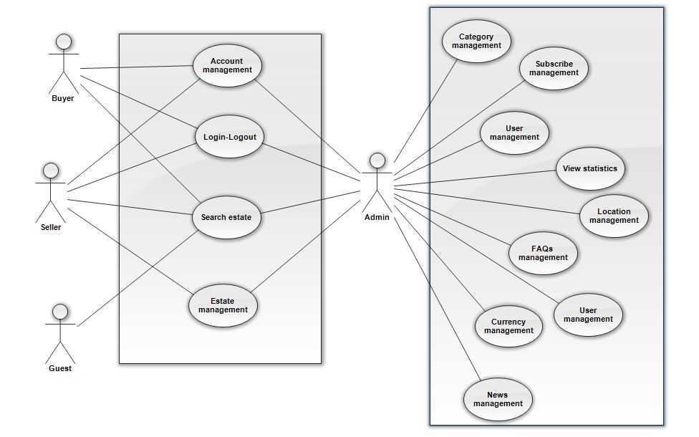

The general

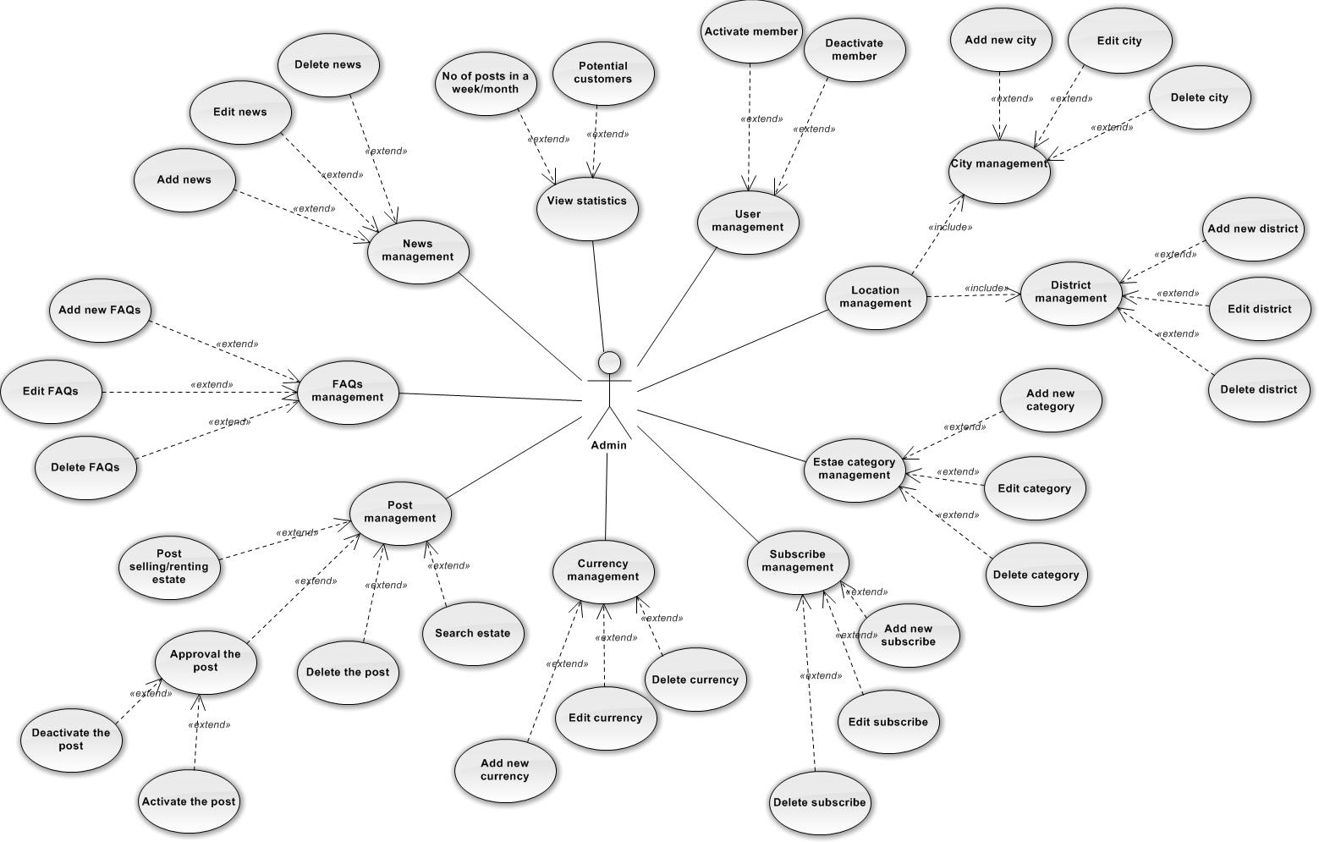
Admin

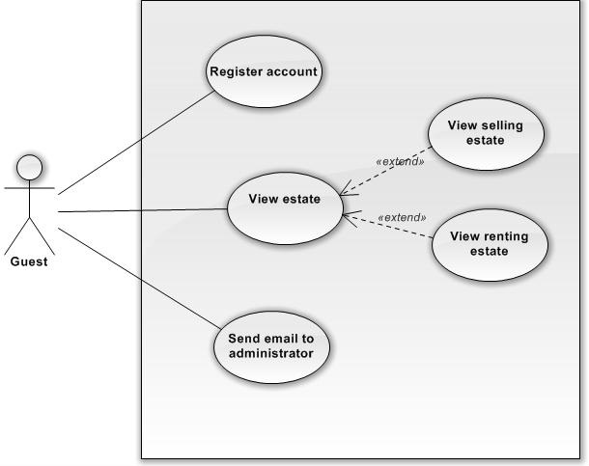
Guest

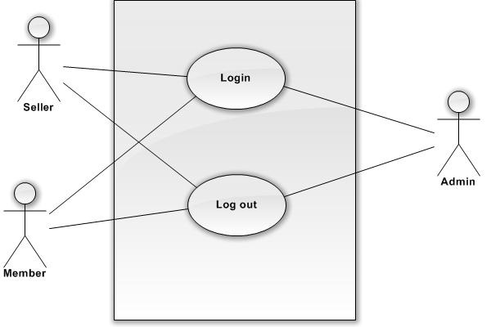

Login-Logout

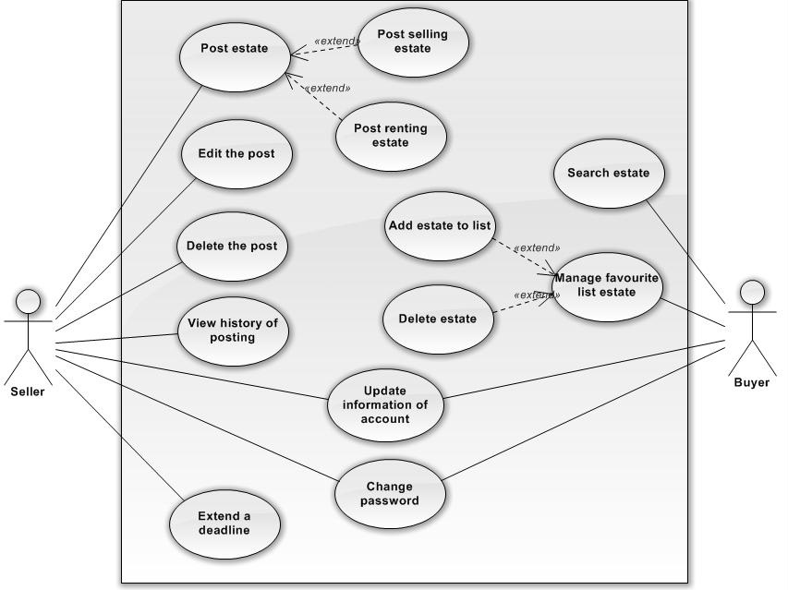

Seller – Buyer

Architecture and Design of the Project

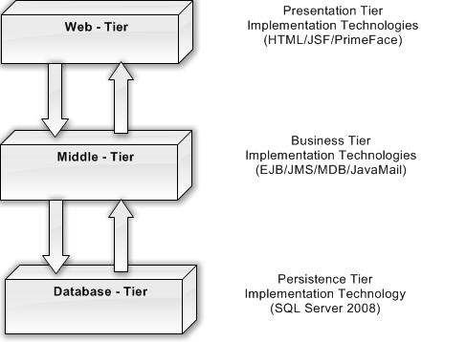

Data Flow Diagram:

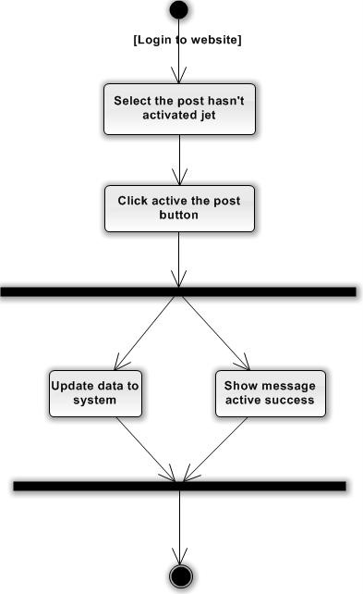

Active the estate

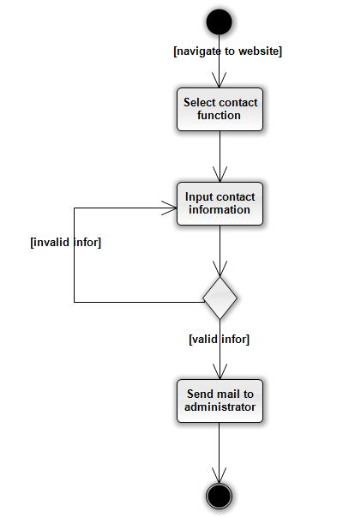

Contact to Admin

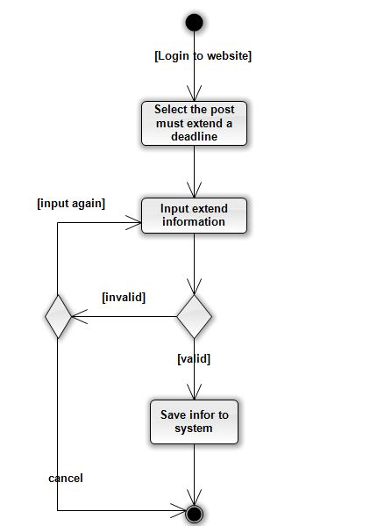
Extend a deadline

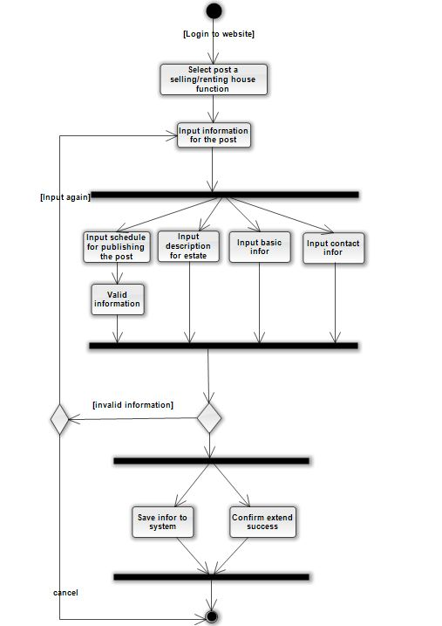
Post a selling renting house

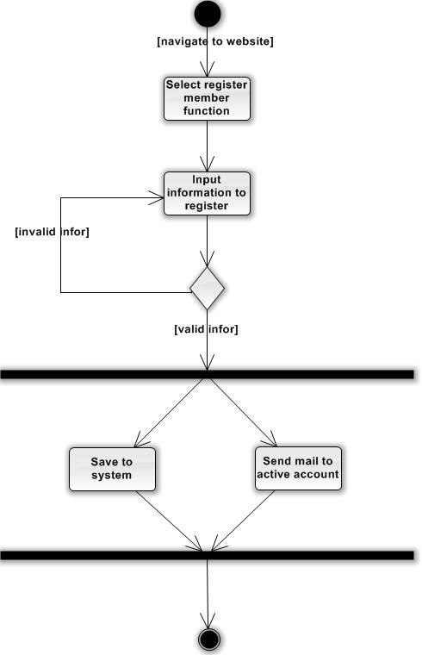

Register member

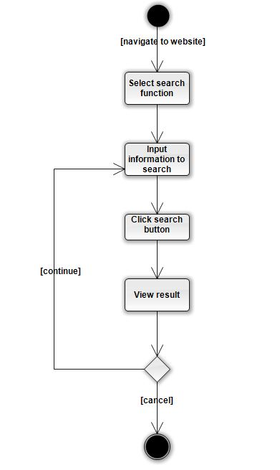

Search estate

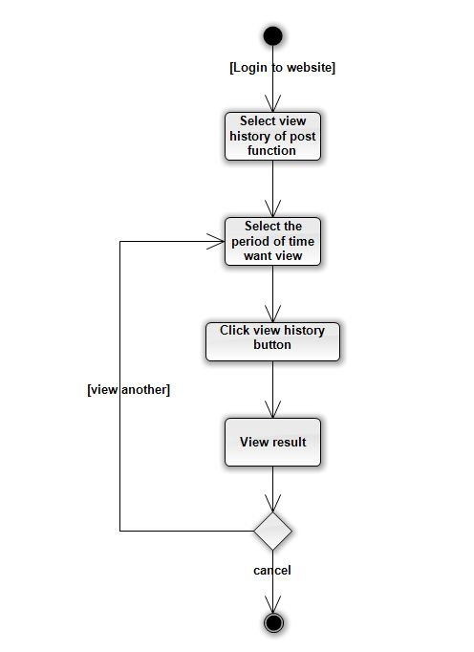

View history of posting

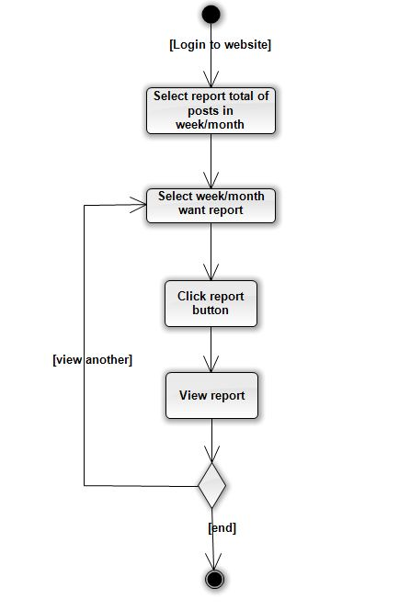

View report in week

- Database Diagram:

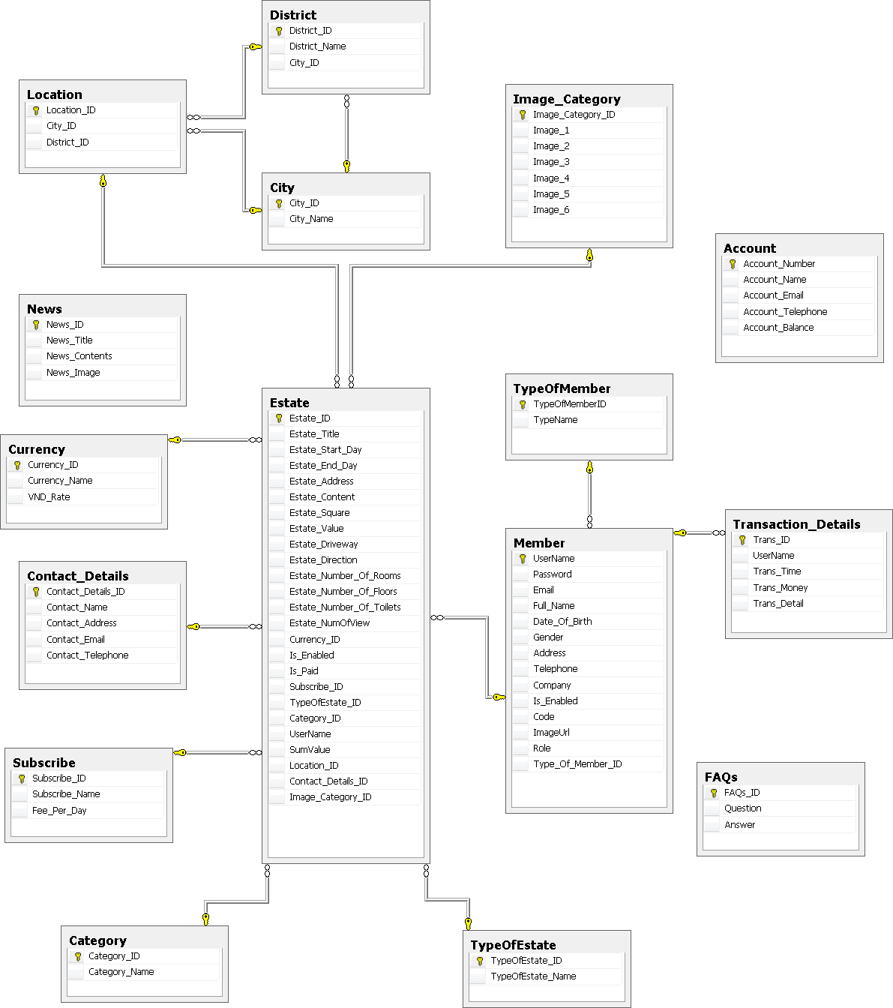

- List of table:

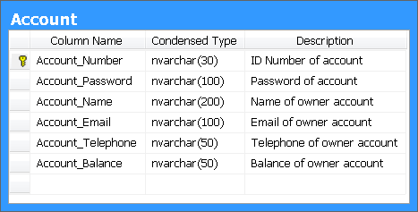

H1: Account Table

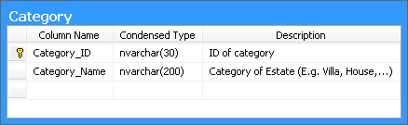

H2: Category Table

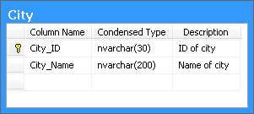

H3: City Table

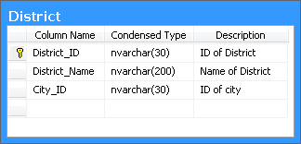

H4: District Table

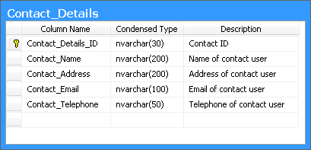

H5: Category Table

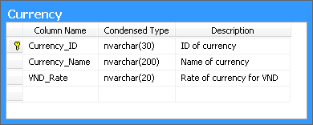

H6: Currency Table

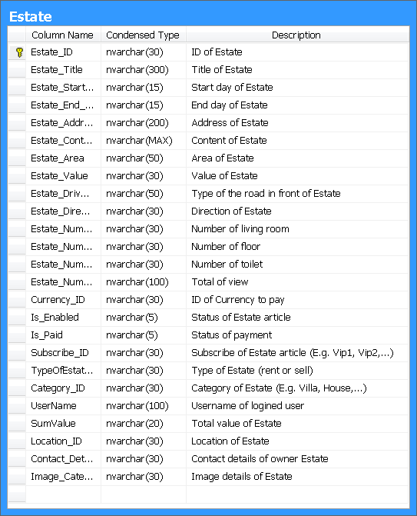

H7: Estate Table

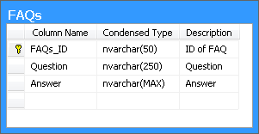

H8: FAQS Table

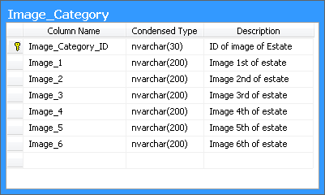

H9: Image_Category Table

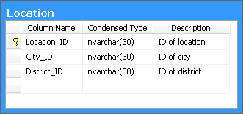

H10: Location Table

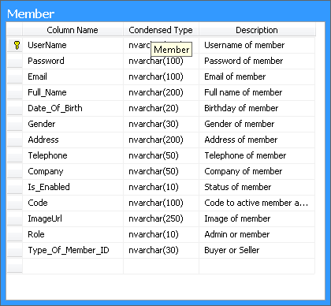

H11: Member Table

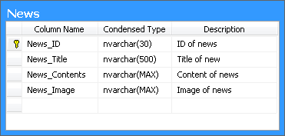

H12: News Table

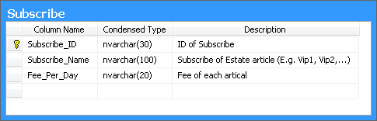

H13: Subscribe Table

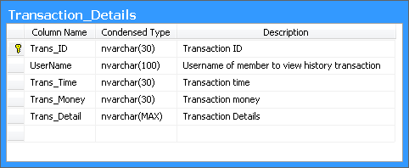

H14: Transaction Table

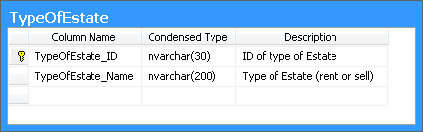

H15: TypeOfEstate Table

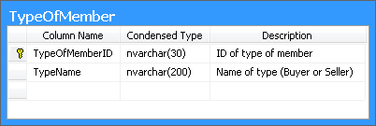

H16: TypeOfMember Table

- Class Diagram
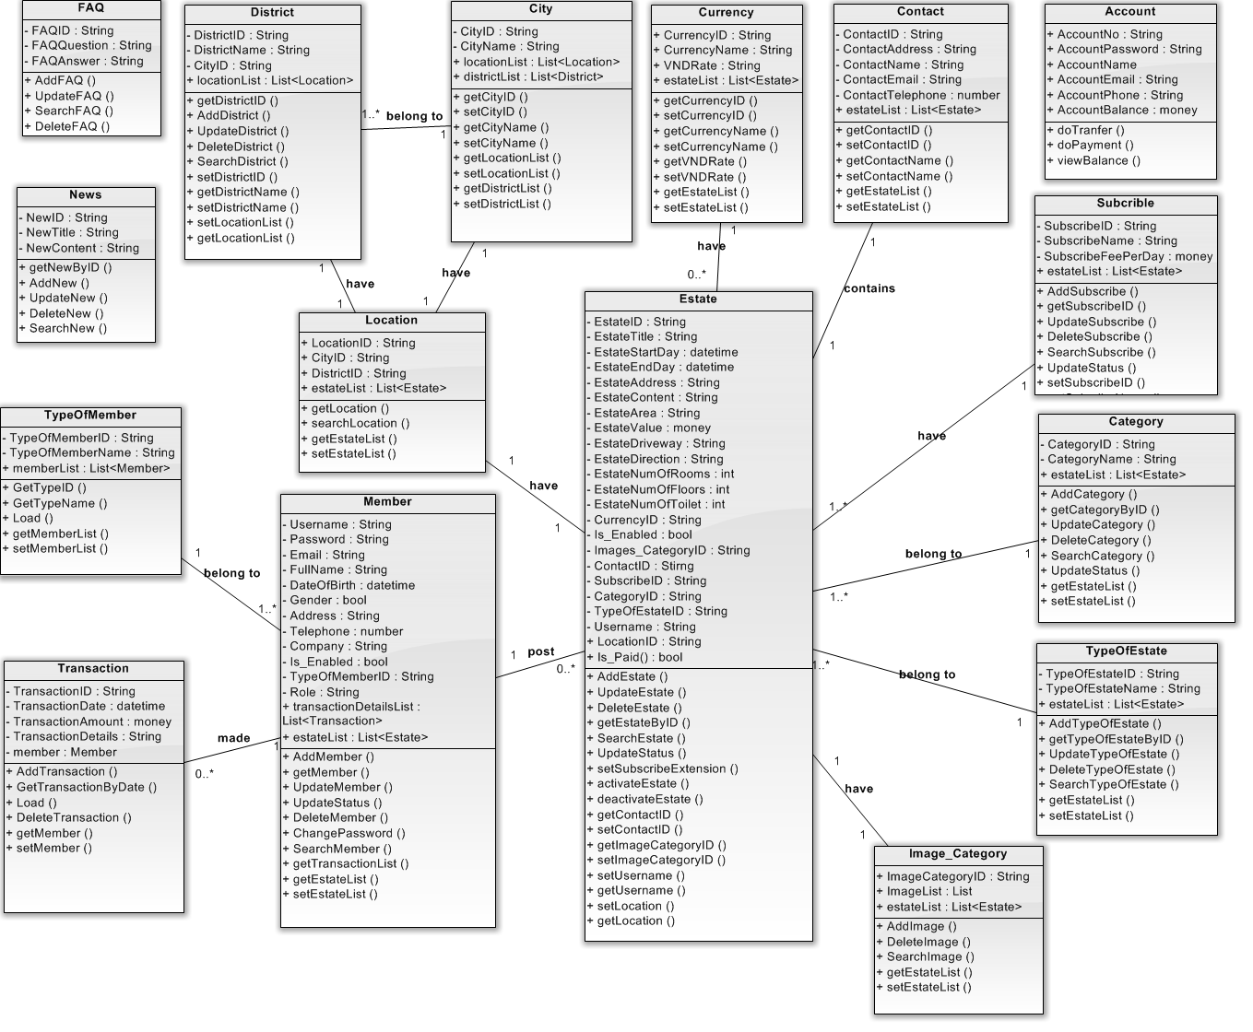
- Sequence Diagram
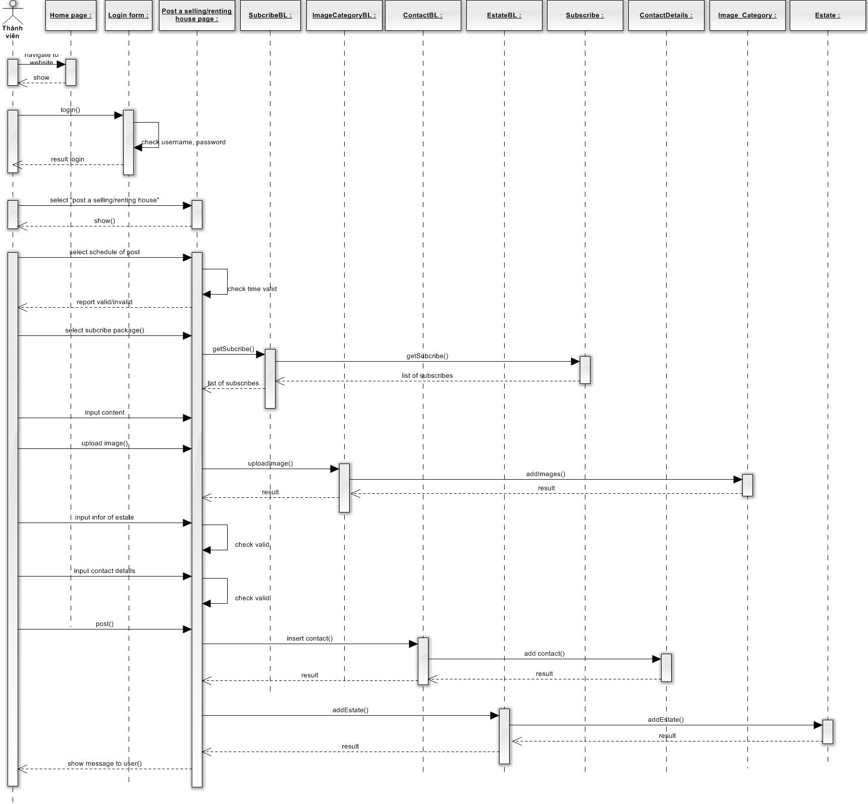
Post a selling and renting house

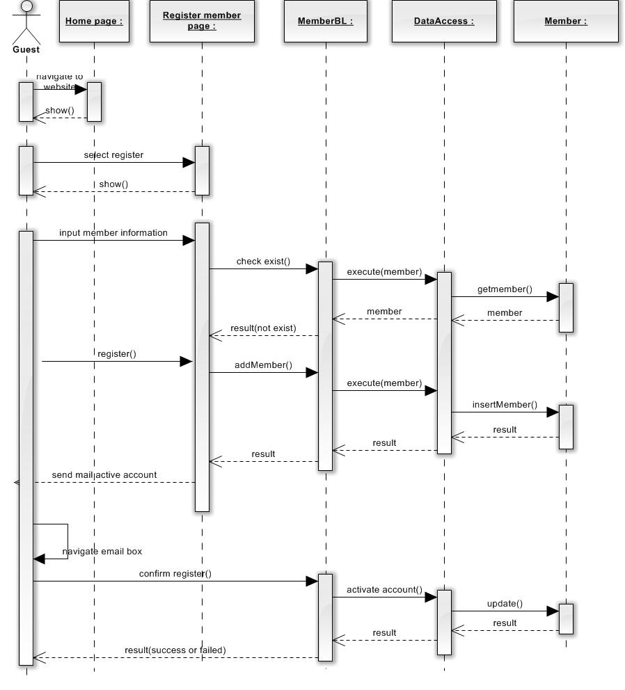
Register member
- Screen shot:



Index page

